TEE CHEMISTRY
Semester 1 Examination 2004
SOLUTIONS

Part 1

1. c | 6. a | 11. c | 16. a
2. c | 7. b | 12. b | 17. c
3. d | 8. c | 13. c | 18. a
4. a | 9. b | 14. b | 19. c
5. a | 10. a | 15. b | 20. a

Part 2
1 (a)
Equation OH ⁻ (aq) + H⁺ (aq) → H₂O ()

Observation Test tube feels warm

(b)
Equation Cu⁺²(aq) + 2OH ⁻(aq) → Cu(OH)₂ (s)

Observation When the colourless solution is added to the pale blue solution a pale blue ppt forms

(c)
Equation 2H₂O₂() → 2H₂O(l) → + O₂(g)

Observation Small colourless bubbles appear on the surface of the black solid

2.
Methanamine, CH₃NH₂  H | Polar of Non Polar?
H  H  C  N  H  H | POLAR
2–  3  Carbonate ion, CO | Polar or Non Polar?
– 2  O  O  C  O | NON POLAR

3.

Substance | Electrical conductivity |  |  | Solubility in water | Colour of solid | Name of substance
Substance | Solid | Liquid | Water solution | Solubility in water | Colour of solid | Name of substance
A | nil | conducts | conducts | soluble | white | Sodium Chloride
B | nil | nil | nil | soluble | white | Sucrose
C | conducts | conducts | –– | insoluble | pink | Copper
D | nil | conducts | –– | insoluble | white | Aluminium Carbonate

4. (a) HCO₄ → H⁺ + CO₄ –

[H⁺] = 0.05m

pH = –log₁₀0.05

= 1.30

(b) Ba(OH)₂ → Ba⁺² + 2OH –

[H⁺] = 2 × 0.05 = 0.1

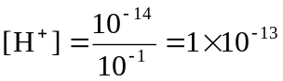
pH = –log₁₀ [H⁺] = –log₁₀ 1 × 10⁻¹³

= 13

5.
SUBSTANCE | STRONG ACID | WEAK ACID | DILUTE ACID | CONCENTRATED ACID
0.05 mol L^{–1} H₂CO₃ |  | ✓ | ✓
10 mol L^{–1} HCl | ✓ |  |  | ✓
10 mol L^{–1} CH₃COOH |  | ✓ |  | ✓
1.0 mol L^{–1} H₂SO₄ | ✓ |  | ✓

6. (a) The amount of CO(g) is more
Explanation Rate of reverse reaction decreases (lower concentration of H₂Og) But rate of forward reaction decreases more resulting in less collisions since both H₂ and CO(g) have lower concentration.

(b) The amount of CO(g) is more
Explanation Both reaction rates will decrease but the forward endothermic reaction decreases more.

(c) The amount of CO(g) is the same as before
Explanation The increased surface changes rates forward and back to the same extent. There are no changes in concentration
PART 3
(a) m(ppt) = 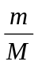 = 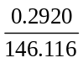 = 0.001998 moL
n(Ca⁺⁺) = n(Ca) = n(ppt) = 0.001998 moL
m(Ca) in 0.4367g sample = n x M
= 0.001998 x 40.08
M(CaC₂O₄.H₂O)
Ca 40.08
C 24.02
O 64.00
H₂ O 18.016
146.116
= 0.08 g

% Ca in sample = 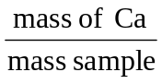x 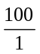
= 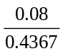 x
= 18.3%

(b) Total m(ppt) = m(calcium precipitate) + m(other)
This would give % Ca too high

2. (a) n(CO₂) = 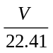 = 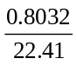 = 0.03584 moL = n(C)

%C = 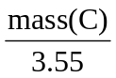 x = 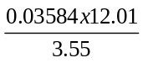 x = 12.125%
M AgC
Ag 107.9
C 35.45
143.35
n(AgC) = 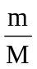 = 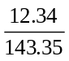 = 0.08608 moL = n(C)

% (O) in samples = 100 – (12.125) + 71.63)

= 16.245%

 | C C O
% by mass  Moles  Simple Ratio | 12.125 71.63 16.245  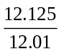 = 1.01 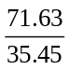 = 2.02 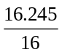 = 1.02  1 2 1
EF = C C₂O

(b) Density = 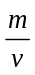 = 4.42gL^{–1} (STP)
Molar Volume is 22.41 L (STP) so molar
mass is M = density x 22.41
= 99.05 g moL ^{–1}

E.F Molar Mass
C = 12.01
C₂ = 35.45
= 35.45
O = 16.00
98.91 g moL^{–1}
Which is close to true molar mass (99.05 g moL ^{–1})
EF = True Formulae = C C₂O

3.
OH – + H ⁺ → H₂O
Ba (OH)₂ + H₂C₂O₄ → 2H₂O + BaC₂O₄
1moL 1moL

(a) n(H₂C₂O₄ ) = n(Ba(OH)₂)= CxV
(20m) = 0.103 x 14.3 x 10⁻³
= 1.4729 x 10⁻³ moL

n( H₂C₂O₄ )= 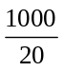 x 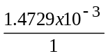 = 0.07365 moL
1000ml and
100ml (original)

So C(H₂C₂O₄) =
(original)
= 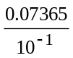 = 0.736M

(b) n(H₂C₂O₄ ) per litre = 0.73645 moL
original
m (H₂C₂O₄) = nx M
= 0.73645 x 90.036
= 66.3g

4.
(a) Pb⁺² _{(aq)} + 2C⁻⁻ _{(aq)} → Pb C₂(s)

(b) n(Pb⁺²) = n Pb(NO₃)₂ = CxV = 150 x 10^{–3} x 0.2
= 30 x 10 ^{–3} moL
n(C–) = n(KC) = CxV = 350 x 1O^{–3} x 0.5
= 175 x 10^{–3} moL
From Equn 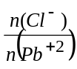 =

From Data 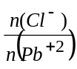 = 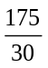 = 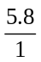 so we have

excess C – and Pb⁺² is L.R

From Equn n (PbC₂) = n(Pb⁺²) = 30 x 10^{–3} moL

So mass (PbC₂) = n x M = 30 x 10^{–3} x 278.1
= 8.34 g

(c) The K⁺ and NO₃– remain in soln and the excess C– also
Total volume is 500 ml
So [K⁺] = 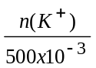 = 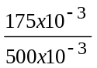 = 0.350 molL⁻¹

[NO₃–] = 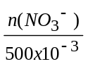 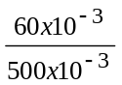 = 0.120 molL⁻¹

n(C–) = n(C–) – n(C –)
Excess Original Used
nC– = 2n(Pb⁺²) = 60 x 10^{–3} moL
(used) (used)
n(C–) = 175 x 10^{–3} – 60 x 10^{–3}
Excess = 115 x 10^{–3} moLs
[C⁻] = 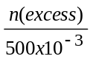 = 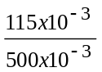 = 0.230 molL⁻¹

For answers to the Part 4 please see the section containing Extended Answer Questions

